**Name: Adithya M SRN: PES1UG20CS621 Section: K**

**Week 9**

1. DELIMITER $$

CREATE TRIGGER trigger1

BEFORE INSERT ON compartment

FOR EACH ROW

BEGIN

IF (SELECT COUNT(*) FROM compartment WHERE Train_Number = NEW.Train_Number) >= 4 THEN

SIGNAL SQLSTATE '50001' SET MESSAGE_TEXT = 'Max number of compartments reached';

END IF;

END; $$

DELIMITER ;

INSERT INTO compartment VALUES("F01","Class I",12,8,58450); 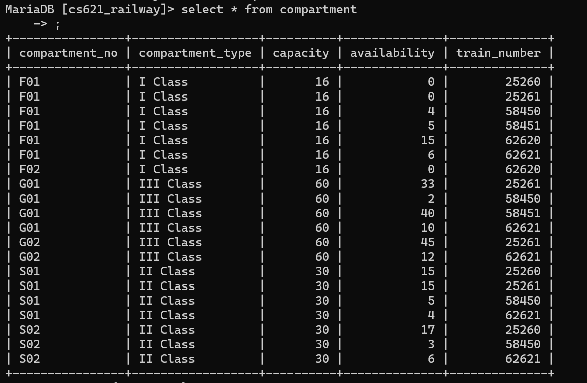



1. create table Back_Up(pnr varchar(10),train_number int, travel_date date,departure varchar(30),arrival varchar(30),departure_time time,arrival_time time, user_id varchar(20),train_type varchar(20), compartment_type varchar(10),compartment_no varchar(10),seat_no varchar(10),name varchar(30),age int(11), transaction_id int,bank varchar(20),card_no varchar(20),price int);

ALTER TABLE Ticket_Passenger ADD CONSTRAINT dt FOREIGN KEY (pnr) REFERENCES Ticket(pnr) on delete cascade;

ALTER TABLE Payment_info ADD CONSTRAINT dp FOREIGN KEY (pnr) REFERENCES Ticket(pnr) on delete cascade;

DELIMITER $$

CREATE TRIGGER del_ticket

BEFORE DELETE

ON Ticket FOR EACH ROW

BEGIN

INSERT INTO Back_Up (SELECT * FROM (Ticket NATURAL JOIN(Ticket_Passenger NATURAL JOIN Payment_info)) WHERE pnr=old.pnr);

END; $$

DELIMITER ;

delete from Ticket where pnr="PNR005";

SELECT * FROM Back_Up;

